PRESS RELEASE | 24 May 2015

High Commissioners of Britain and Australia end visit to Chars Livelihoods Programme (CLP)

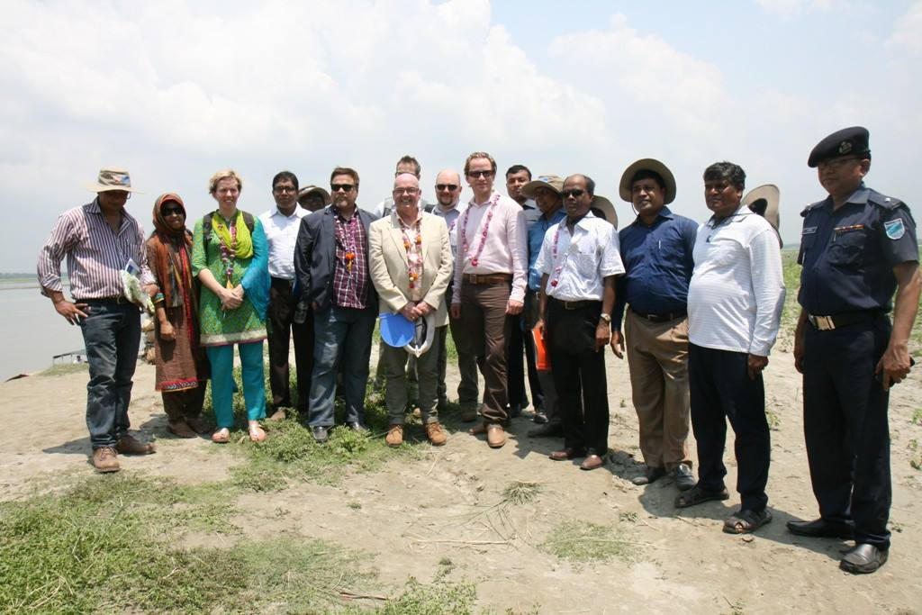
British High Commissioner Robert Gibson & Australian High Commissioner Greg Wilcock concluded their two-day visit to Chars Livelihoods Programme (CLP) in Tangail and Bogra on 19 May.
The Chars Livelihoods Programme (CLP) which aims to improve the livelihoods, incomes and food security of 1 million extremely poor and vulnerable women, children and men on island chars in north western Bangladesh. It provides a comprehensive package of support to the extremely poor, as well as extending support to the wider char community. The CLP is jointly funded by UKaid through the Department for International Development (DFID) and by the Australian Government through the Department of Foreign Affairs and Trade (DFAT). It is implemented in partnership with the Ministry of Local Government, Rural Development and Cooperatives (LGRD&C) of the Government of the People’s Republic of Bangladesh.
Describing what he saw, British High Commissioner Robert Gibson said:
‘‘This was the first time I have visited the chars and I was struck by how fragile the environment is. We met many households who have been forced to move their home many times to escape the floods. I saw with my own eyes is how CLP has and is making a real and sustainable difference to poor people’s lives.
.

At the end of his visit, Australian High Commissioner Greg Wilcock said:

“I was struck by what the Chars Livelihoods Programme has been able to help char dwellers strengthen and build: their homes, health, assets, businesses, and communities. In so doing, CLP has also built the resilience of these communities amid a difficult natural environment. Australia is proud to have supported CLP.”

Notes to editors:
- So far CLP 2 has delivered the following results:
- About 167,000 people (more than 43,000 households), of which more than half are women and girls, lifted out of extreme poverty.
- More than 248,000 people ( more than half women and girls) protected from flooding by raising more than 63,800 homes on earth plinths;
- Almost 75,000 families received a one-time transfer of productive assets benefiting more than 290,000 people to improve their livelihoods, more than half women and girls
- More than 488,000 people have now access to sanitary latrine
- About 365,000 people have now access to safe water
- More information on the CLP can be found here: http://clp-bangladesh.org/
- See the development tracker to explore international development projects funded by the UK Government in Bangladesh.
- British High Commissioner is active on Twitter: @HCRobertGibson
.

